**Digital Image Processing Lab**

**CEL-445**

Lab Journal: 2



Name: OMAR

Class: BCE-07

Enrollment No: 01-132182-024

**INTRODUCTION:**

* **Digital Image Processing:**

Digital image processing deals with manipulation of digital images through a digital computer. It is a subfield of signals and systems but focus particularly on images. DIP focuses on developing a computer system that is able to perform processing on an image. The input of that system is a digital image and the system process that image using efficient algorithms and gives an image as an output. The most common example is Adobe Photoshop. It is one of the widely used application for processing digital images.

* **Image:**

An image is defined as a two-dimensional function F(x, y), where x and y are spatial coordinates, and the amplitude of F at any pair of coordinates (x, y) is called the intensity of that image at that point. When x, y, and amplitude values of F are finite, we call it a digital image. In other words, an image can be defined by a twodimensional array specifically arranged in rows and columns.

Digital Image is composed of a finite number of elements, each of which elements have a particular value at a particular location. These elements are referred to as picture elements, image elements, and pixels. A Pixel is most widely used to denote the elements of a Digital Image.

• **Types:**

* + BINARY IMAGE – The binary image as its name suggests, contain only twopixel elements i.e., 0 & 1, where 0 refers to black and 1 refers to white. This image is also known as Monochrome.

* + BLACK AND WHITE IMAGE – The image which consist of only black and white color is called black & white image.

* + 8-bit COLOR FORMAT – It has 256 different shades of colors in it and commonly known as Grayscale Image. In this format, 0 stands for Black, and 255 stands for white, and 127 stands for gray.

* + 16-bit COLOR FORMAT – It is a color image format. It has 65,536 different colors in it. It is also known as High Color Format. In this format the distribution of color is not as same as Grayscale image.

* **Task:**

**Take a blur image and apply different filters on it to sharp the image. CODE:**

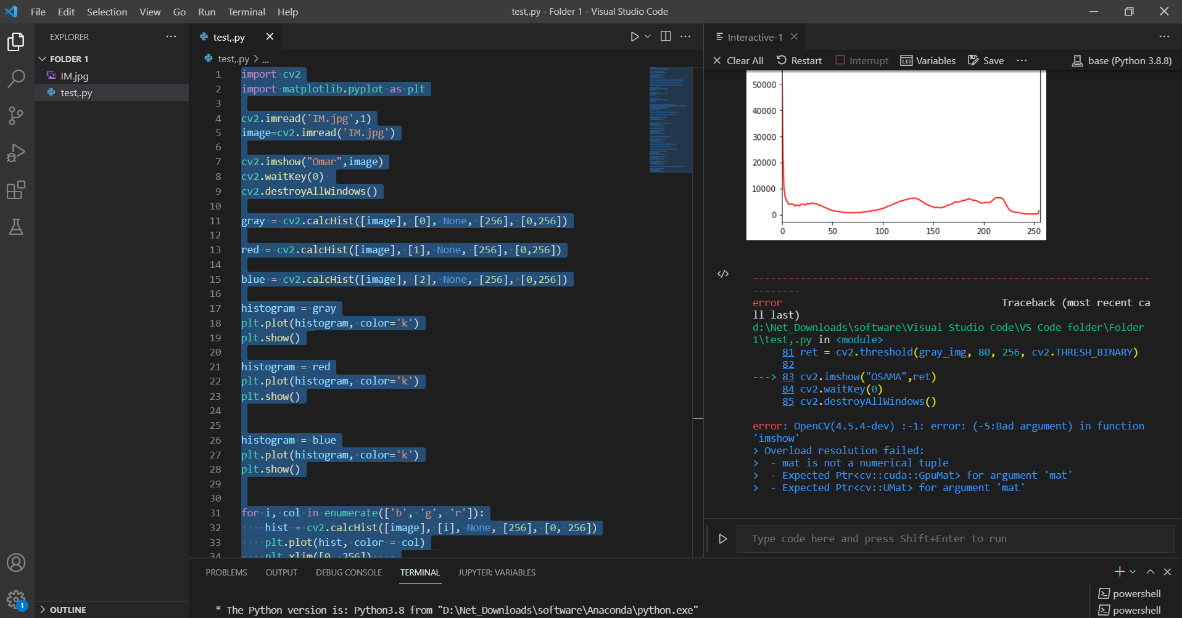

import cv2

import matplotlib.pyplot as plt

cv2.imread('IM.jpg',1)

image=cv2.imread('IM.jpg')

cv2.imshow("Omar",image)

cv2.waitKey(0)

cv2.destroyAllWindows()

gray = cv2.calcHist([image], [0], None, [256], [0,256])

red = cv2.calcHist([image], [1], None, [256], [0,256])

blue = cv2.calcHist([image], [2], None, [256], [0,256])

histogram = gray

plt.plot(histogram, color='k')

plt.show()

histogram = red

plt.plot(histogram, color='k')

plt.show()

histogram = blue

plt.plot(histogram, color='k')

plt.show()

for i, col in enumerate(['b', 'g', 'r']):

    hist = cv2.calcHist([image], [i], None, [256], [0, 256])

    plt.plot(hist, color = col)

    plt.xlim([0, 256])

    plt.show()

gray_img=cv2.cvtColor(image,cv2.COLOR_BGR2GRAY)

gray_img_eqhist=cv2.equalizeHist(gray_img)

cv2.imshow("OSAMA",gray_img)

cv2.waitKey(0)

cv2.destroyAllWindows()

cv2.imshow("OSAMA",gray_img_eqhist)

cv2.waitKey(0)

cv2.destroyAllWindows()

flip = cv2.flip(image, 0)

cv2.imshow("OSAMA",flip)

cv2.waitKey(0)

cv2.destroyAllWindows()

blurImg = cv2.blur(image,(10,10))

cv2.imshow("OSAMA",blurImg)

cv2.waitKey(0)

cv2.destroyAllWindows()

gausBlur = cv2.GaussianBlur(image, (5,5),0)

medBlur = cv2.medianBlur(image,5)

bilFilter = cv2.bilateralFilter(image,9,75,75)

cv2.imshow("OSAMA",gausBlur)

cv2.waitKey(0)

cv2.destroyAllWindows()

cv2.imshow("OSAMA",medBlur)

cv2.waitKey(0)

cv2.destroyAllWindows()

cv2.imshow("OSAMA",bilFilter)

cv2.waitKey(0)

cv2.destroyAllWindows()

ret = cv2.threshold(gray_img, 80, 256, cv2.THRESH_BINARY)

cv2.imshow("OSAMA",ret)

cv2.waitKey(0)

cv2.destroyAllWindows()

**OUTPUTS:**

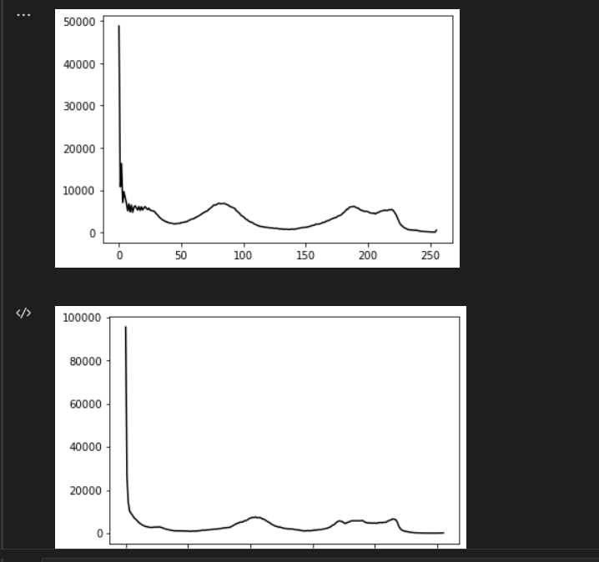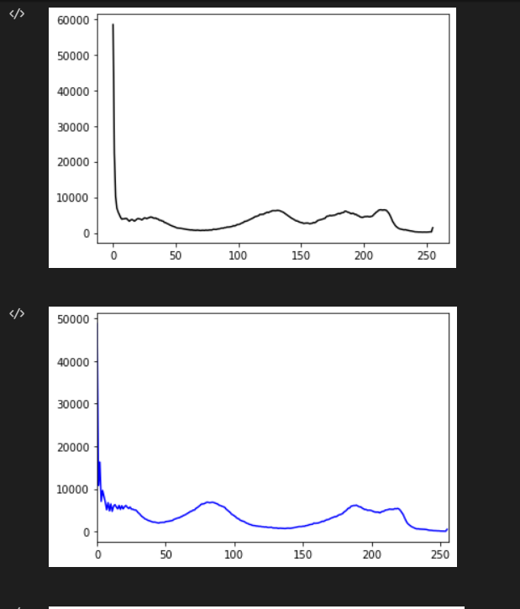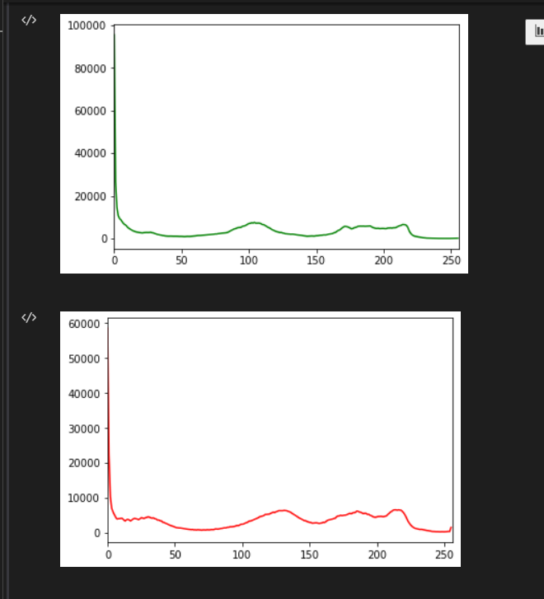

**Image(original):**

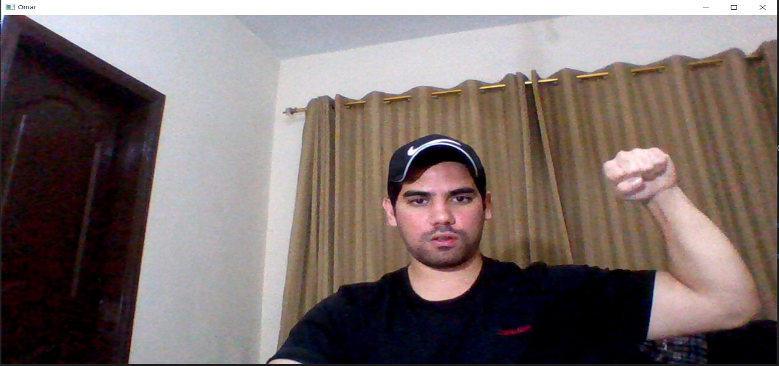

**Grey scale:**

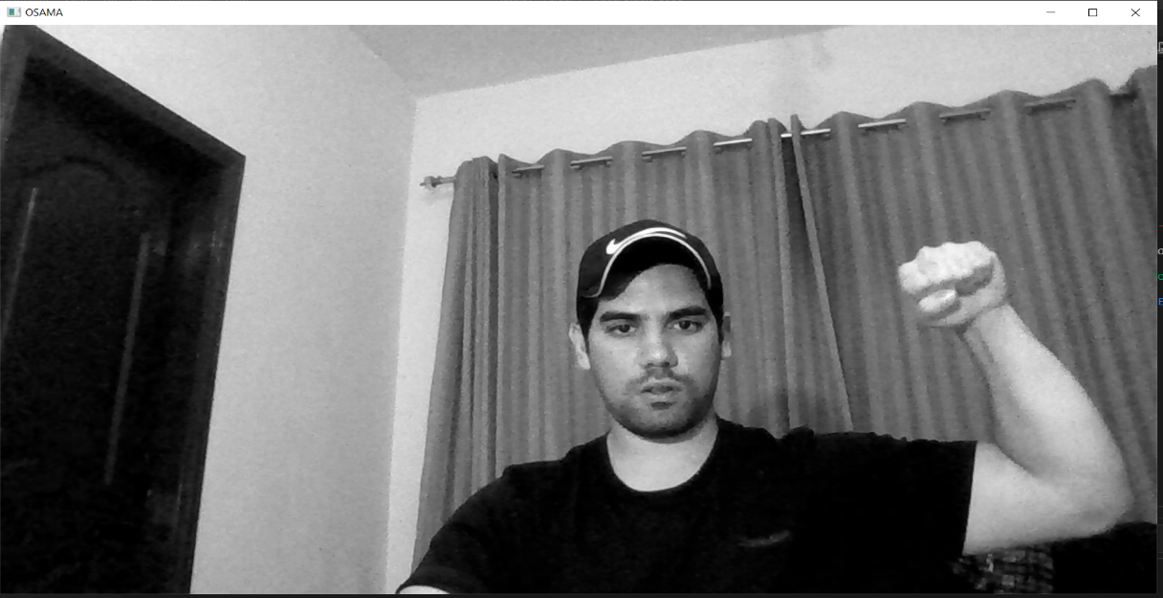

**Flip:**

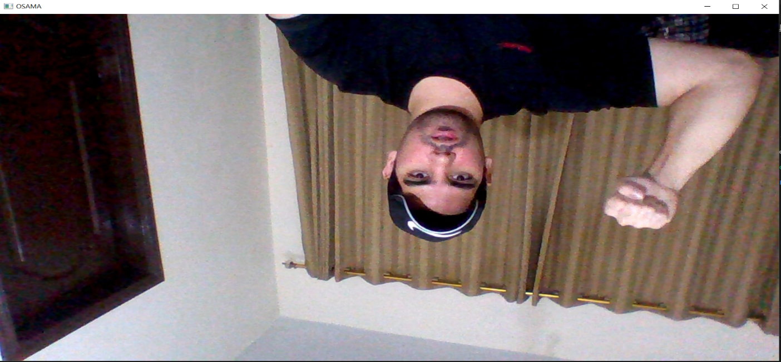

**Blur:**

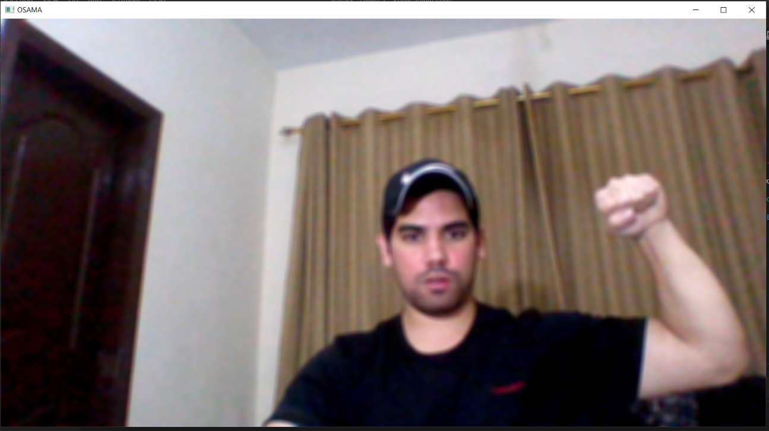

**Sharp:**

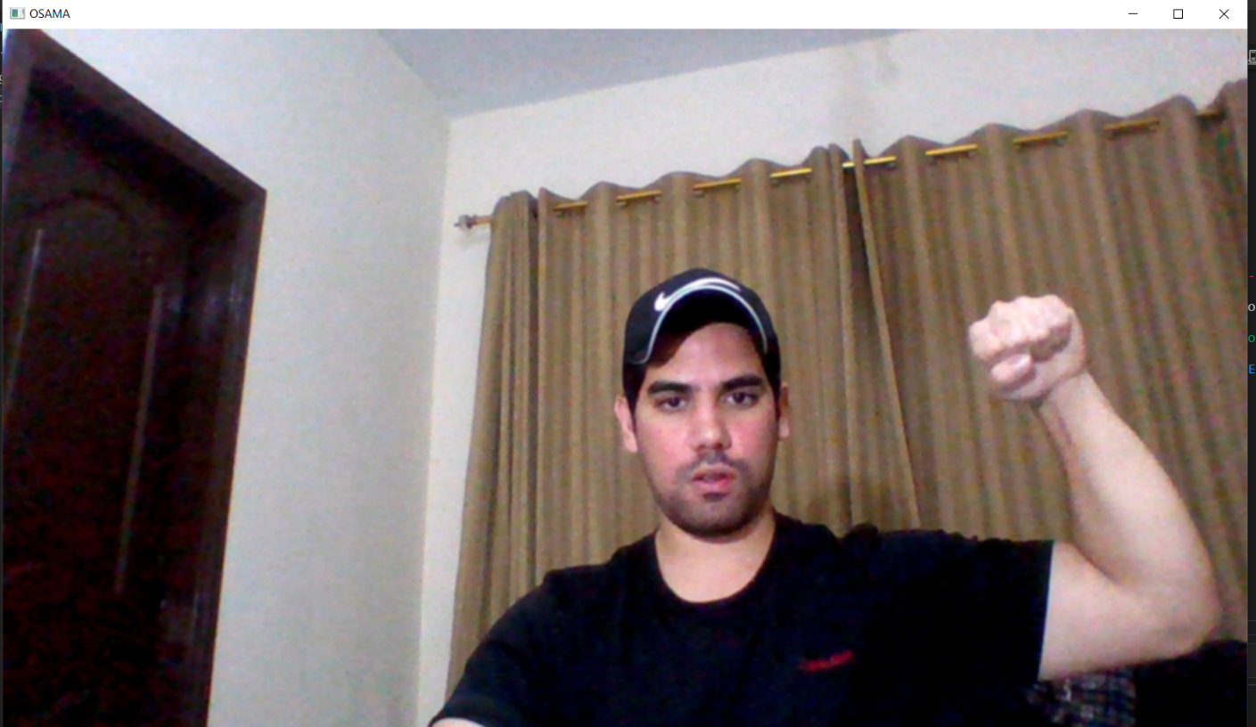

* **Conclusion:**

In this lab we learned about Digital Image Processing and some of the functions that we can perform on an image file such importing, grey scaling, flipping, and blurringan image file. This was a very interesting lab and we learned a lot in this lab.